Cole Hutchins
Chelsea Ensley
ENGL 2089
8 August 2021
My Career as a Reader
As a kid, all I did was read. I was constantly at my limit for library books checked out and always had books in mind to read after. I was usually seen with a book in hand and during primary school had read 50 books a year multiple times. Reading was my biggest passion, and I loved getting lost in stories. I attended a small private school that was a thirty-minute drive from my house, which gave me a guaranteed two hours a day to read accounting for the drive to sports practice most days. My parents and schools helped foster and nourish my passion for reading, which thrived for the better part of a decade, and this passion sadly faded away due to a busy schedule and change of life interests
My love for reading was inspired by my parents. They introduced me to books before I could even comprehend what was being to read to me. They would read picture books to me at first, then short stories, and then longer books at a lower reading level. They would read part of a book or a short story to me almost every night before I fell asleep. Once I started learning to read, they read with me, helping me with the words I couldn’t quite grasp yet. Within a year or two of learning how to read, it became a major hobby of mine. I was always begging my parents to take me to the library to check out books, and my reading level was progressing quickly. I started to fall in love with fantasy series, such as Percy Jackson, Harry Potter, The Chronicles of Narnia, and more. I would read on the way to school, during class, on the way home, and as soon as my homework was finished, my book was opened. I even once got lost on a school field trip due to reading and walking away from the group. I was reading while we were moving from one area of a building to another and mistook another class for mine as I had my nose in my book. By the time I had realized it was too late, and I had accidently become a part of another class. Thankfully, I was able to play it off as a bathroom break once I found my class again.
My school was a catalyst for my reading passion. They had an extensive library and programs that incentivized you to read with the lure of points and prizes. I felt encouraged to read, from my parents, school, schoolmates, and the overall environment. At the end of the year, they even recognized students who read a certain number of books, an achievement that was then pictured in the yearbook, as seen below.
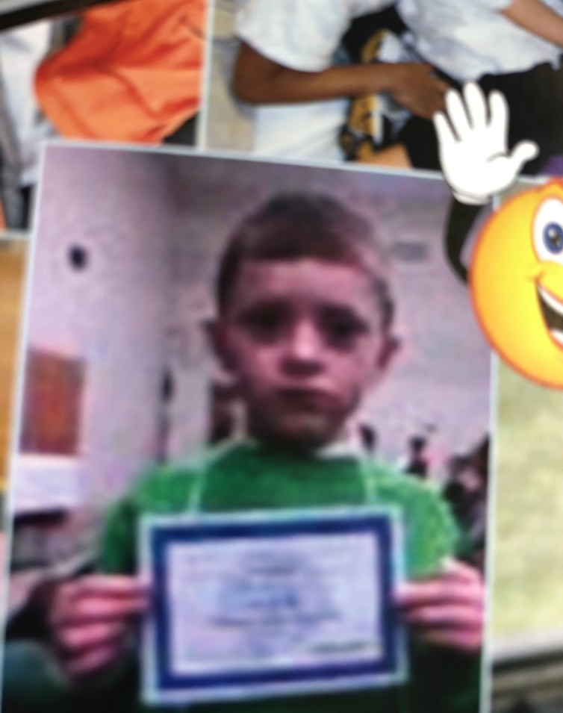
The school used a program that would quiz you on books that you had read, and if you got enough questions right, you were awarded points. These points could be redeemed for prizes, and also were used in calculations for awards and honors.
During the summer after third grade, my family moved. My school changed along with my friends and environment. This school was a lot larger than my previous one and was renowned for its academic and athletic prowess. I immediately took up several new sports and made new friends. A lot of my interests changed; however, my passion for reading persisted. I was a very outgoing and friendly person, but even with the influx of new people and extracurriculars, I continued to read just as much. The new school’s library as even larger than my former school’s, and the librarian was very friendly and great with helping me pick out good books. She helped steer me towards several of my all-time favorite series of books and had a lot of knowledge of what books people my age enjoyed. We frequently visited the library during English class for short videos or lessons taught by the librarian, and then afterwards were free to wander the library, which I often did.
The peak of my literacy career was likely right around this time-period. My writing had matured enough to where I could write long coherent essays, and my quantity of reading had never been higher. I was a prolific reader during my early middle school years, even to the point where I was winning reading contests ran through our school, one of which allowed me to attend a really cool event held by the Cincinnati Bengals. The event was called “The Taste of the NFL”, and I was able to take my two closest friends and taste a variety of food and meet several of the Bengal players, which was a great experience. I was excelling in English class, partially due to my advantage of having a great grammar education from my first school. I was writing most of my free-write essays about sports, a hobby of mine to both play and watch which allowed me to get very invested into my writing. My middle school years were full of reading both at home and during school, but as high school approached, my interests started to shift.
The year before high school started, I decided that I wanted to play soccer for the high school. I had played soccer as a kid but stopped in middle school after a series of bad experiences. I decided I wanted to pick up soccer again and started practicing as well as running to get conditioned. This took up several hours of my day during the end of eighth grade and took up even more time during summer once school practices started. Once I started practicing with the team, I made several friends with some of my to-be teammates. I started to hang out with some of the guys after practice and on the weekends, as well as play pick up soccer with them. Once school started in the fall, soccer would take up at least twenty hours of my time a week, and the increase in schoolwork meant that I had less and less free time. This certainly cut into my time for reading, but I still made an effort to read books outside of the required English titles. I distinctly remember asking my ninth grade English teacher for book recommendations, and acting upon these recommendations which lead me to a newfound interest in books that told the tale of remarkable scientific feats and discoveries. After reading The Immortal Life of Henrietta Lacks, a remarkable novel about how an African American’s stolen cancer cells are some of the most important ones used in medical research, and Brain on Fire, a book about a young women who develops an extremely rare disease and used her experience to hep others, I was hooked on the genre and my level of interest in science and reading were piqued. I was now sharing time between schoolwork, soccer, socializing, and reading, which was the most I had ever balanced before.
Once soccer season ended, one would have expected me to return to my middle school self in terms of hobbies, reading, and overall personality. However, the influx of new people, a semester on a sports team, and the overall high school experience had a great effect on me. I had become a lot more social person and was hanging out with my new soccer friends and new friends from classes. I even started playing soccer year-round, which had become a bigger hobby than I anticipated. This majorly affected my reading habits. The reduction in free time, and shift in interests, caused my hobby on reading for pleasure to be deprioritized. I didn’t notice much at the time but can now see that the books I read were mostly restricted to the ones assigned during summer or read for class. This resulted in any books read for fun to be related, either by genre or topic, to what we were reading or just had read in class. I would read several books about science and history, and then have a random interest in books about famous wars, followed by perhaps another surge in interest in novels in the science fiction genre. My interests had started to be guided mainly by an outside source, instead of my own interests that I developed. The reduction in free time, shift in interests, and change in inspiration for what I read would ultimately lead to the downfall of my career of reading for pleasure.
My literacy career had its last big run in tenth grade. My tenth grade English teacher was very friendly and had an unending list of recommendations. She inspired my last memorable phase of reading for pleasure and helped me to find a lot of books that I was likely to enjoy. I ended up starting multiple book series, mostly in the sci-fi genre, because of her, and began to invest more time in reading outside of school than I was before. Some of my last memories of reading for pleasure were in her class, reading off of the Kindle app on my phone, or from a book from the school library. Sadly, this year I had even less free time due to both homework and soccer being more time-demanding than before. After about midway through the year, my free time had been diminished enough, and my interests reprioritized to where reading for pleasure was basically nonexistent, a trend that carried its way throughout the rest of my high school years. Apart from a couple books, my upperclassmen literacy career consisted of solely the books reading during class or for summer reading in preparation for a class.
Looking back upon my literacy career, I wish that I would have preserved my hobby of reading for pleasure. I had never truly dissected the reason for its demise before and was very intrigued to discover why it had perhaps died out. I understand why it had happened, and a decrease in my reading for pleasure may have benefited me as a person, as it allowed for more social time and friends to be made, but I wish that time had just decreased and not dissolved, as I had a lot of fun reading when I was younger. During the drafting of this essay, I felt nostalgia towards the day where I would just read for hours on end and just get lost in my book and decided to try to reignite the spark I used to have for reading. I would love to have reading as a hobby again, and feel that it was especially benefit me during prolonged times of being without my friends, which I went through during quarantine and will go through again during my COOP. I went to the library by campus and searched for a book that would allow me to stay interested long enough where I could get lost in it. I spent the most time in a library than I likely have in years, and after reading many online recommendations lists, I decided on The Hobbit.

